ONTARIO
TRILLIUM DRUG
PROGRAM
Fast Facts

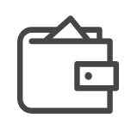
WHAT DO YOU PAY?
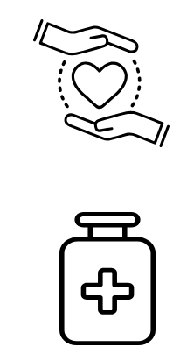
WHAT IS IT?
Annual program for Ontario residents for those with a valid health card.
A fixed rate contribution.
This is calculated from your household income.

Provides financial support for over 3,800 prescription drugs and more.

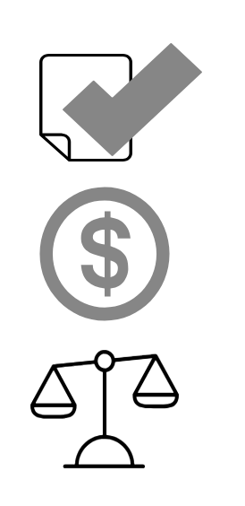
You should apply…
Valid OHIP card

No Private insurance

Private or provincial government insurance doesn’t fully cover cost

Household spends considerable amount on prescription drugs

HOW DO YOU APPLY?
Access the application form ONLINE
http://www.health.gov.on.ca/en/public/programs/drugs/opdp_forms.aspx

Print completed application and MAIL to:

TRILLIUM DRUG PROGRAM
PO BOX 337 Station D
Etobicoke ON M9A 4X3

HOW DO YOU APPLY?
416 642 3038 (Toronto area)
1 800 575 5386 (Toll-free)
1 800 387 5559 (TTY)
Hours: Monday to Friday 9am to 5pm

TRILLIUM DRUG PROGRAM
PO Box 337 Station D
Etobicoke ON M9A 4X3
trillium@ontariodrugbenefit.ca

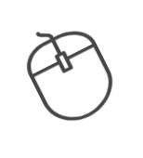
For more information, visit this website: http://www.health.gov.on.ca/en/public/programs/drugs/programs/odb/opdp_trillium.aspx

