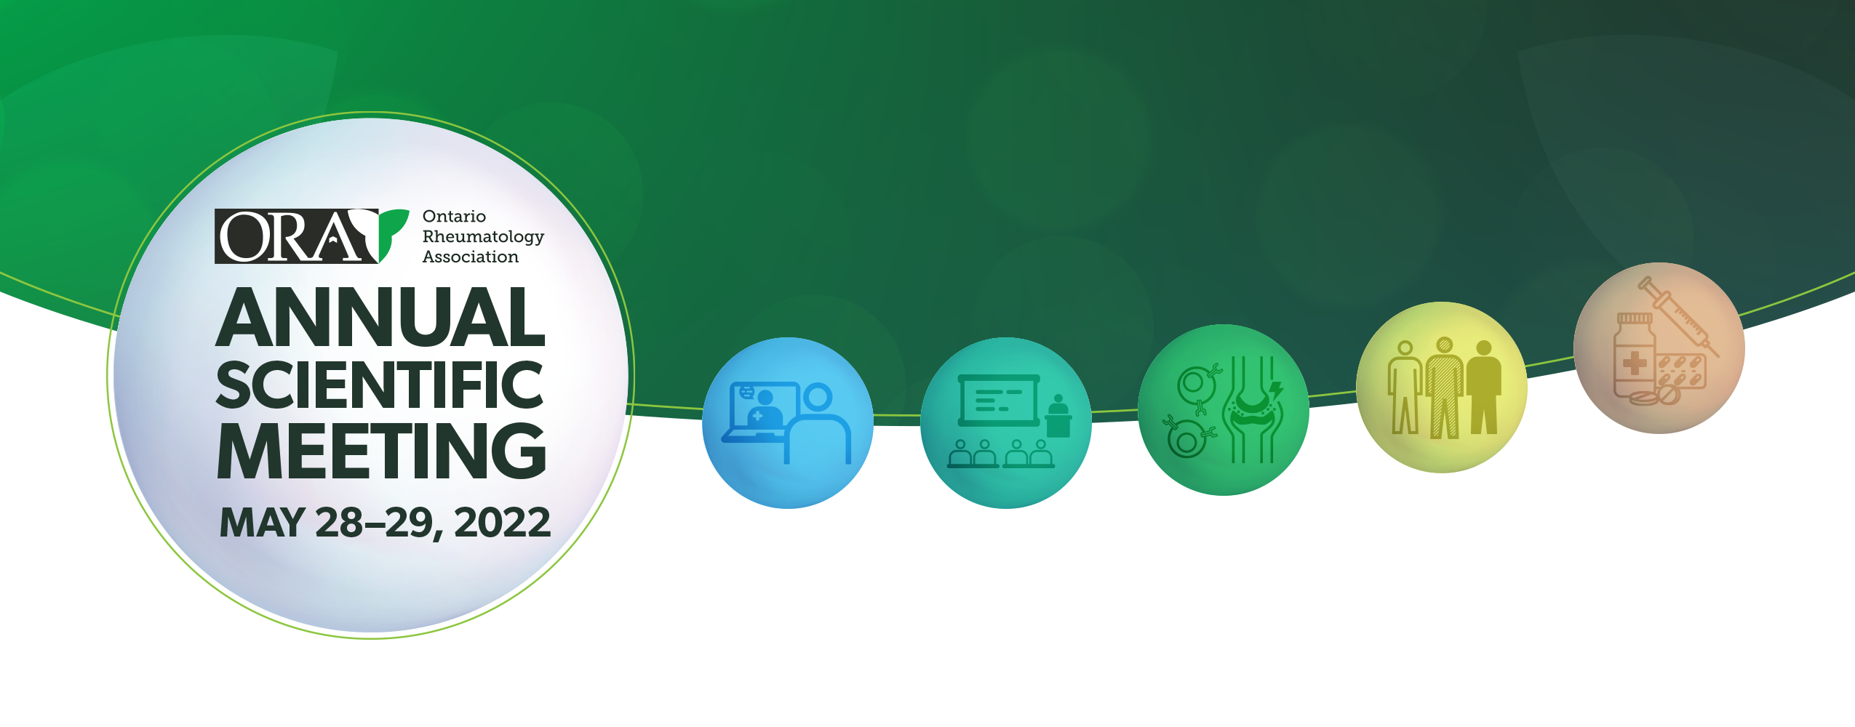

Practice Pearls in Rheumatology

MEETING LEARNING OBJECTIVES
By the end of the meeting, participants will be able to:
- Discuss recent developments in the diagnosis and management of rheumatic diseases;
- Appraise new rheumatologic treatment paradigms and practice resources; and
- Foster greater provincial peer mentorship and collaboration
The theme of this year’s meeting is Practice Pearls in Rheumatology. The meeting will enable participants to engage in both clinical and scholarly activities with the objective of improving the quality of care in Ontario for patients with rheumatic diseases.

INDIVIDUAL SESSIONS
 | Session & Speakers | Learning Objectives
Saturday  Plenary Sessions | State of the Art in PsA   Dr. Laura Coates | - By the end of the respective session, participants will be able to:  - Participants will review data on new medications in development for PsA and their indications (in different tissues)  - Participants will be able to evaluate new data on treatment strategy and appraise treatment approaches in PsA  - Participants will appraise current data on personalisation of treatment and explore possibilities for the future.
Saturday  Plenary Sessions | State of the Art in RA  Dr. Iain McInnes | By the end of the respective session, participants will be able to:  - To be able to discuss recent advances in the understanding of the clinical progression of RA  - To be informed as to examples of recent advances in the understanding of the pathogenesis of RA  - To be able to discuss future developments towards new therapeutics in RA
Saturday  Plenary Sessions | The role of imaging in the diagnosis and differential diagnosis of axial spondyloarthritis  Dr. Denis Poddubnyy | By the end of the respective session, participants will be able to:  - Participants will be able to rank imaging methods according to their relevance for the diagnosis and differential diagnosis of axial spondyloarthritis.  - Participants will be able to describe spondyloarthritis-typical abnormalities on imaging (X-ray and MRI) if sacroiliac joints.  - Participants will be able to differentiate degenerative / mechanical changes from true inflammatory changes on imaging of sacroiliac joints.

Saturday  Plenary Sessions | Using routinely collected health data to evaluate quality of care & outcomes prior to & during the pandemic  Dr. Jessica Widdifield | By the end of the respective session, participants will be able to:  - Recognize the value of using routinely collected health data to address gaps in knowledge about quality of care & outcomes of rheumatic diseases.  - Acknowledge the gaps in data and limitations of using health administrative data to evaluate quality of care & outcomes of rheumatic diseases.  - Appreciate the role of aggregating EMR data to fill gaps in knowledge and gaps in data to enhance our understanding of quality of care & outcomes of rheumatic diseases.
Saturday  Plenary Sessions | Diversity in Rheumatology  Dr. Nicole Johnson | By the end of the respective session, participants will be able to:  - To define steps for psychological safety in discussing racism and health inequities  - To list examples where diversity and health inequities exist in rheumatology  - To explain cultural humility and its role in improving health outcomes for diverse populations  - To reflect on the rheumatology providers’ need for structural competency to address health inequities.
Sunday  Plenary Sessions | Practice Pearls in Managing Patients with Long COVID  Dr. Mark Bonta | By the end of the respective session, participants will be able to:  - Describe the mechanism of bodily injury caused by COVID-19  - Summarize the long term sequelae of COVID-19 infection  - Define Long COVID  - Summarize an approach to managing patients with symptoms attributed to prior COVID-19 Infection
Sunday  Poster Session | Poster Session   Dr. Irena Doubelt,  Dr. A.J. Teel, Leslie Laing, Maria Tauqir | By the end of the respective session, participants will be able to:  - Review novel research and clinical investigations of Canadian rheumatology healthcare professionals  - Discuss implications of current research and evidence  - Identify opportunities for future explorations and collaborations
Sunday  Workshops Breakouts | Practice Pearls in ILD  1  Dr. Gerard Cox | By the end of the respective session, participants will be able to:  - Discuss the prevalence of ILD in CTDs  - Review the typical clinical and radiological presentations of ILDs in CTDs  - Discuss management options for patients with progressive ILD
Sunday  Workshops Breakouts | Navigating Immune Medicated Ocular Complications  2   Dr. Janet Pope  & Dr. Carter Thorne | By the end of the respective session, participants will be able to:  - To become familiar with various ocular complications of immune mediated diseases.  - To ensure that optimal care occurs with respect to a care pathway including inter-specialty communication
Sunday  Workshops Breakouts | Practice Pearls in Sports Medicine  3  Dr. Clair LeBlanc | By the end of the respective session, participants will be able to:  - Be aware of 6 sport medicine conditions  - To distinguish pediatric from adult overuse injuries  - Be familiar with treatment strategies for these conditions
Sunday  Workshops Breakouts | Practice Pearls in Non-invasive Imaging & Autoimmune Liver Disease  4  Dr. Paul Marotta | By the end of the respective session, participants will be able to:  - Update on the diagnostic criteria and treatment options for Autoimmune Liver Diseases.  - Demonstrate how Advanced Liver Imaging techniques can assist in management of rheumatologic therapies and conditions.

Sunday  Plenary Sessions | Practice Pearls  – A Rheumatology Retrospective Journey  Dr. Brian Feldman | By the end of the respective session, participants will be able to:  - Understand the challenges associated with studying therapies in rare diseases.  - Learn about alternative clinical trial designs to address problems faced when studying rare diseases.  - Learn about statistical models (causal models) used to get rigorous estimates of therapeutic effectiveness from chart data.
Sunday  Workshops Breakouts | Long COVID  – Bring a Case  1  Dr. Mark Bonta | By the end of the respective session, participants will be able to:  - Define clinical symptoms congruent with prior COVID-19 Infection  - Apply management strategies to patients with symptoms related to prior COVID-19 Infection  - Summarize the principles of management for patients with medically unexplained physical symptoms
Sunday  Workshops Breakouts | Inflammatory Arthritis  – Bring a Case  2   Dr. Garrett Robson, Dr. Emily Mckeown | By the end of the respective session, participants will be able to:  - Analyze challenging real-world Difficult IA case presentations;  - Identify optimal peer-developed clinical management insights and strategies
Sunday  Workshops Breakouts | CTD  – Bring A Case  3  Dr. Stephanie Tom,  Dr. Marie Clements Baker | By the end of the respective session, participants will be able to:  - Analyze challenging real-world Difficult CTD case presentations;  - Identify optimal peer-developed clinical management insights and strategies
Sunday  Workshops Breakouts | “Rare Birds”  – Bring A Case  4  Dr. Raman Joshi, Dr. Sharon Kreidstein | By the end of the respective session, participants will be able to:  - Analyze challenging real-world Difficult Rare Rheumatologic case presentations;  - Identify optimal peer-developed clinical management insights and strategies

The Mission of the Ontario Rheumatology Association is to represent Ontario
Rheumatologists and promote their pursuit of excellence in Arthritis care in Ontario
through Leadership, Advocacy, Education and Communications.

