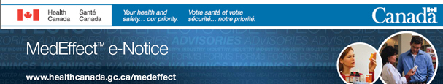  
  
As a subscriber to Health Canada’s MedEffectTM e-Notice, you are being informed of the latest [Health Professional Communication](http://healthycanadians.gc.ca/recall-alert-rappel-avis/hc-sc/2014/41701a-eng.php) and [Public Communication](http://healthycanadians.gc.ca/recall-alert-rappel-avis/hc-sc/2014/41703a-eng.php).   
<http://healthycanadians.gc.ca/recall-alert-rappel-avis/hc-sc/2014/41701a-eng.php>   
<http://healthycanadians.gc.ca/recall-alert-rappel-avis/hc-sc/2014/41703a-eng.php>   
  
**Diclofenac - Update to Heart and Stroke Related Safety Information and Decrease in the Maximum Recommended Daily Dose for Tablets and Suppositories - Novartis Pharma Canada Inc. and Pfizer Canada Inc.**   
  
Diclofenac at 150 mg per day, is associated with an increased risk of serious cardiovascular adverse events. The maximum recommended daily dose of systemic diclofenac is now 100 mg per day. Diclofenac is not recommended in patients with pre-existing cardiovascular or cerebrovascular disease.

[Click here](http://rheum.ca/en/the_cra/drug_updates) to read the Canadian Rheumatology Association bulletin